SQL fundamentals Query Activity:

1. Display the name of movies, movie type is starts with Drama.

>Select moviename from movie wheremovietype like ‘Drama’;

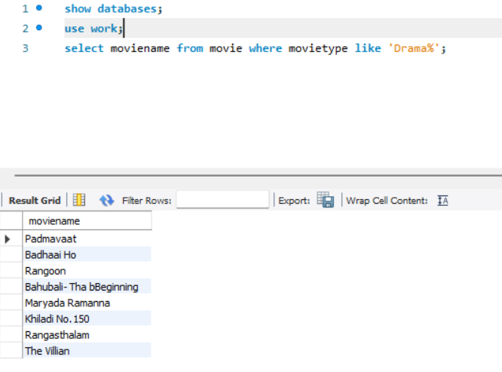

2. Display the movies acted by actor Ayushmann.

>select moviename from movie where heroname = ‘Ayushmann’;

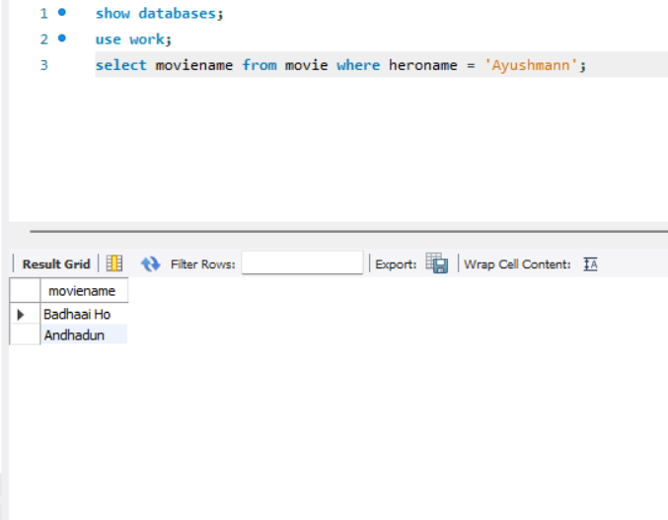

3. Display the count of movies, having length above 18.

>select count(moviename) from movie where length>18;

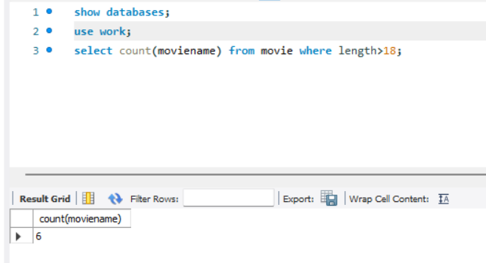

4. Display the movie having minimum length.

>select moviename,heroname,heroine from movie where length=( select min(length) from movie);

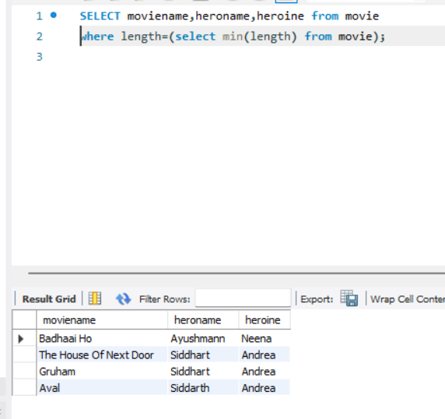

5. Display all the details of movie, the language that first name starts with ‘T

>select \* from movie where language like ‘T%’;

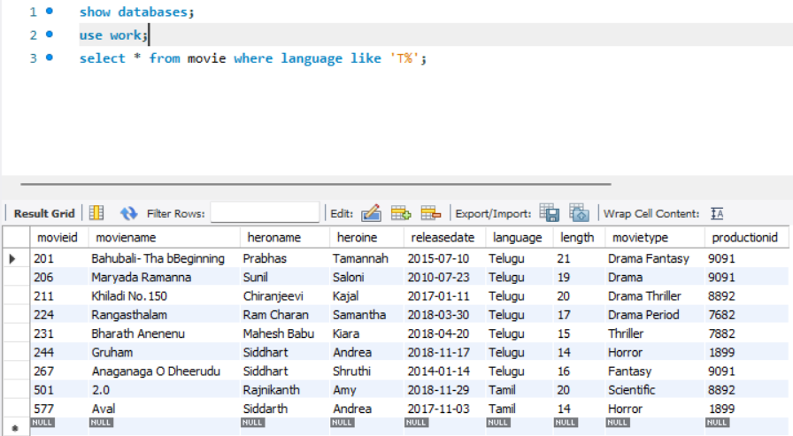

6. Display the movie name, hero name, heroine name whose having maximum length.

>select moviename,heroname,heroine from movie where length(select(max(length) from movie);

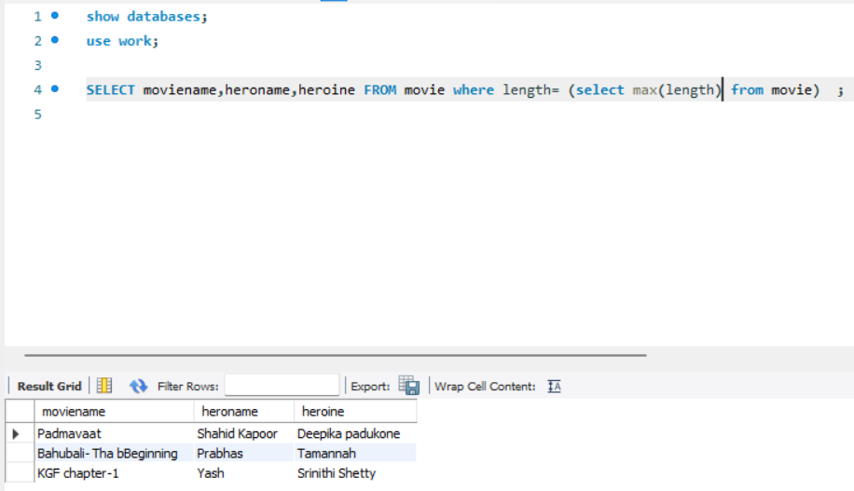

7. Display the movie name, hero name, heroine name the movie released after 15 march 2018.

>select moviename,heroname,heroine from movie releasedate<’2018-03-15’;

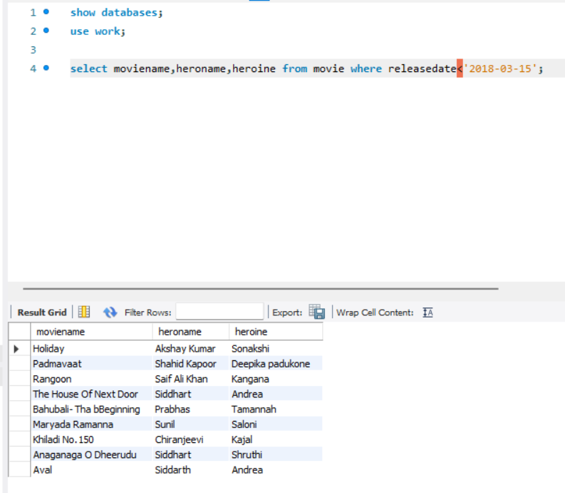

8. Display the count of thriller movies.

>select count(movietype) from movie where movietype=’Thriller’;

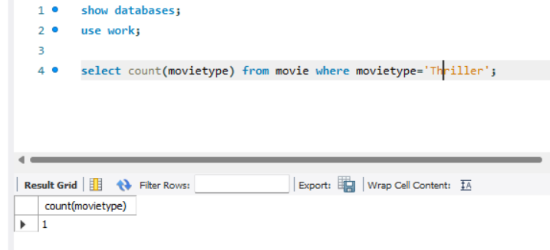

9. Display the count of movies whose released before 15 march 2018.

>select moviename,heroname,heroine from movie where releasedate>’2018-03-15’;

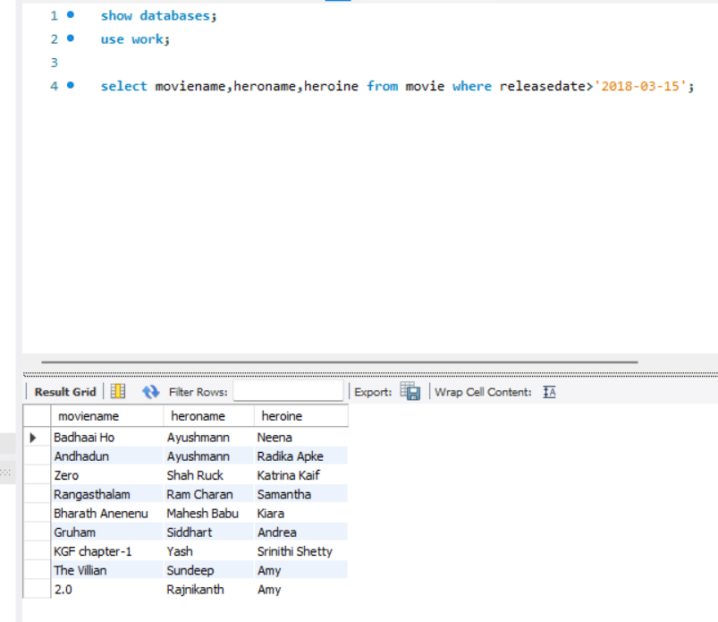

10. Display the release date of the movie name ‘Zero’.

>select releasedate from movie where moviename=’Zero’;

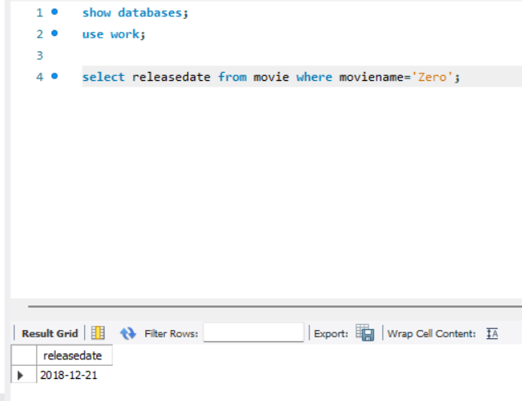

11. Display the actor name that acted with ‘Amy’.

>select heroname from movie where heroine=’Amy’;

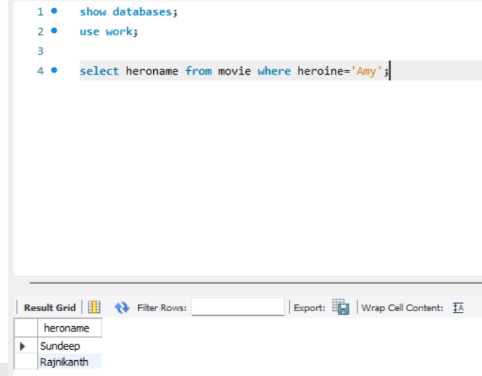

12. Display the Count of maximum movies released in the month of October.

>select count(moviename) from movie where releasedate like ‘%-10-%’;

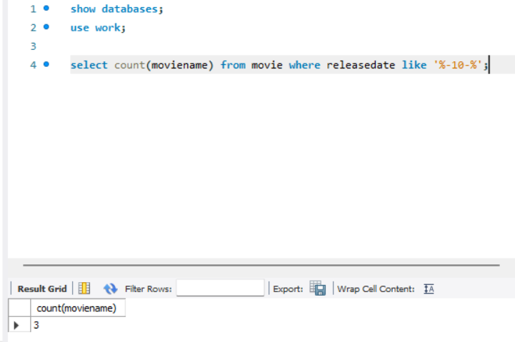

13. Display the movienames whose production id is same for different languages.

>select distinct productionid,moviename,language from movie group by language;

